Java7_Notes:

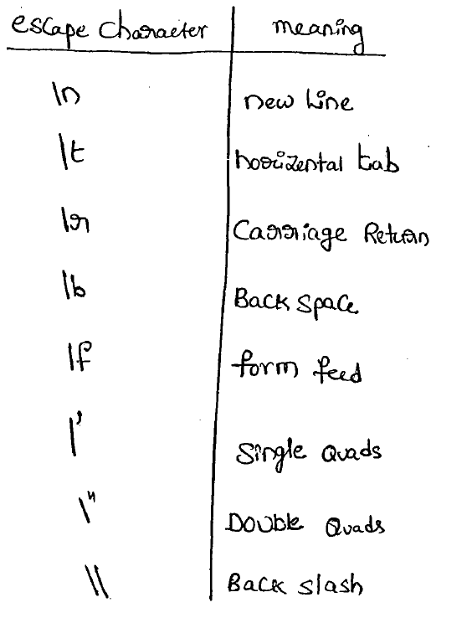

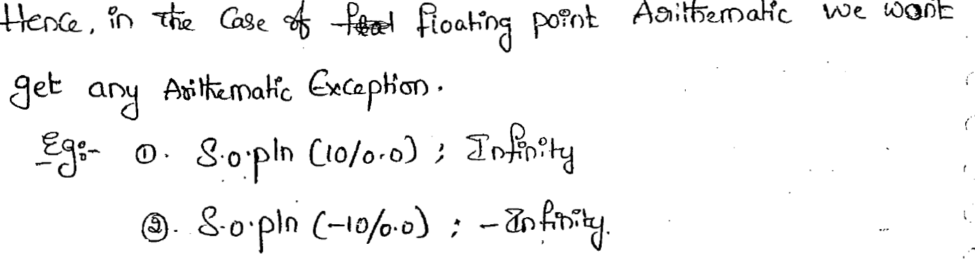

--------------------------------------------------------------------------------------------------------------------------------

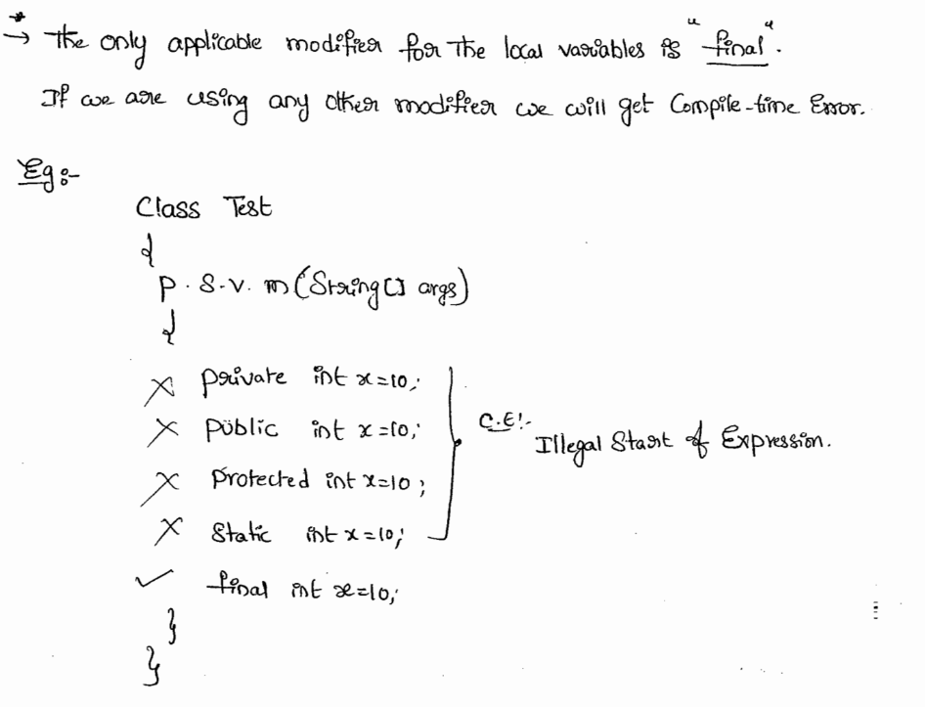

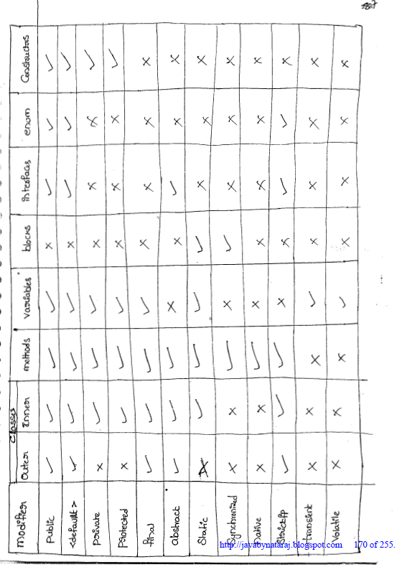

--------------------------------------------------------------------------------------------------------------------------------

**Collection terminology.**

**List**: Insertion odder present and duplicate are allowed

* ArrayList : Resizable Array and default capacity 10 [new capacity= current capacity * (3/2)+1] / Frequent operation is retrieval
* Vector : Resizable Array and all methods are synchronized / Frequent operation is retrieval/ default capacity 10 [new capacity = current capacity * 2]
* LinkedList: Duble Linked list and Frequent operation insertion or deletion
* Stack :

**Set** : No insertion order and duplicates are not allowed

* HashSet : Underlying DS hashtable and default capacity 16 [default fill ratio 0.75 (75%)] /
* LinkedHashSet: Child class of hashset and underlying DS is HashTable and Linked List
* Sortedset :
* TreeSet: Underlying DS is Balanced Tree and

**Map:**

* HashMap : Underlygin DS HashTable and default capacity 16 [default fill ratio 0.75 (75%)]
* HashTable : All methods as synchonized and default capacity 11 [default fill ratio 0.7(70%)]
* LinkedHashMap : Child clas of hashMap and underlying DS is HashTable and Linked List
* IdentityMap : 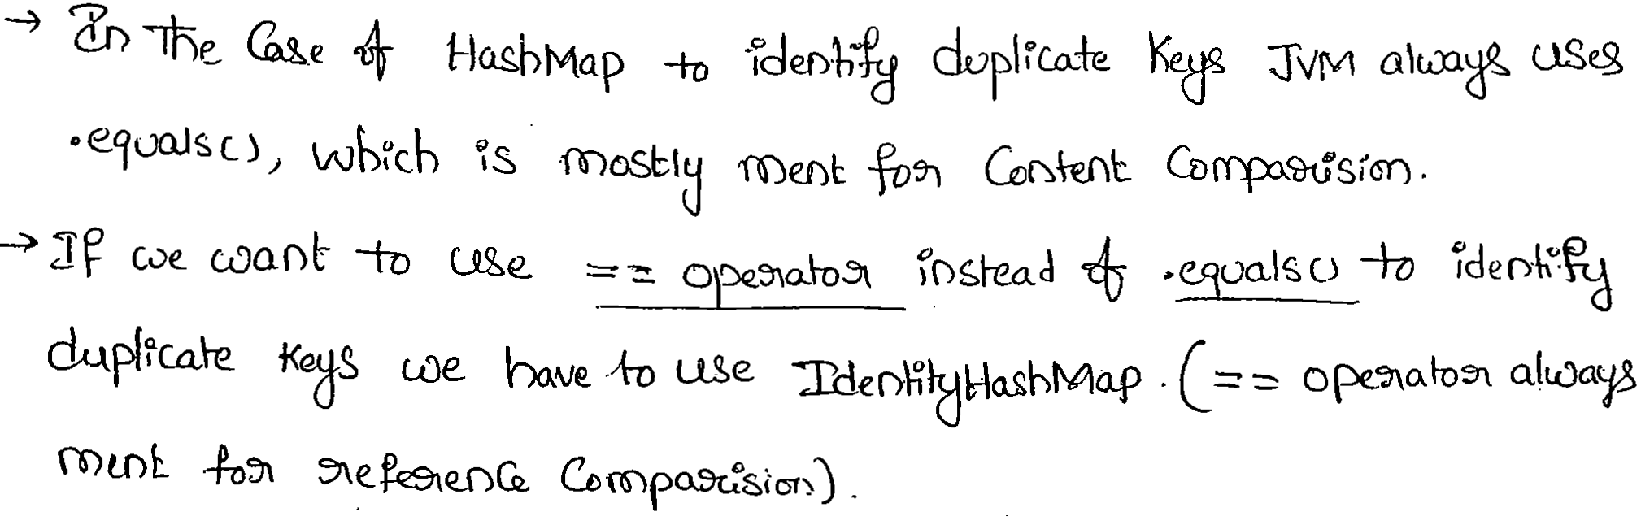

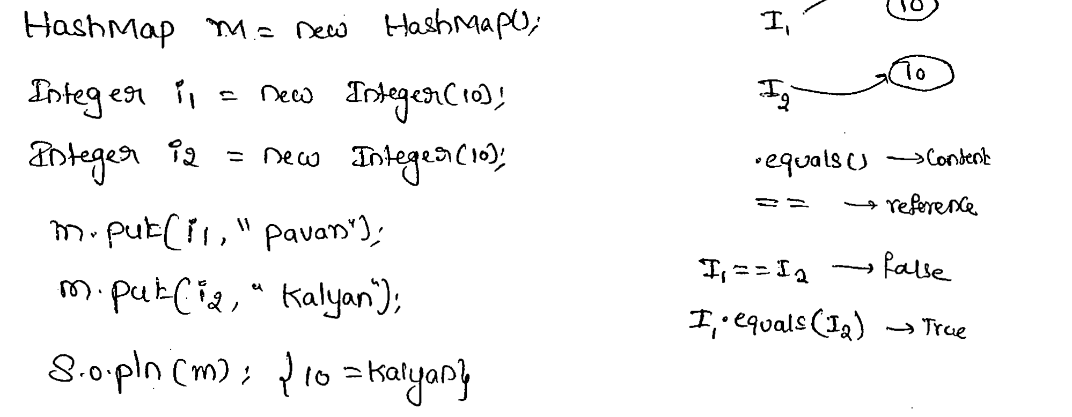 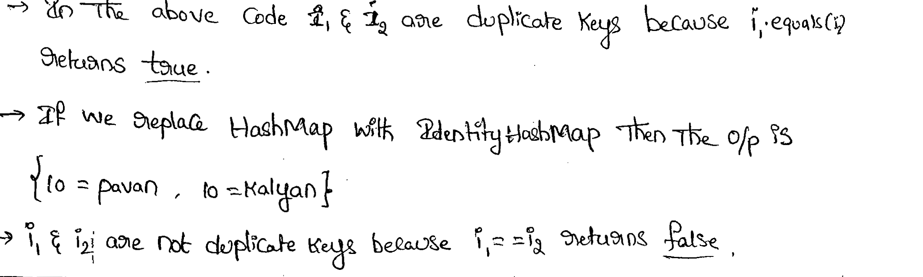

* WeakHashMap: 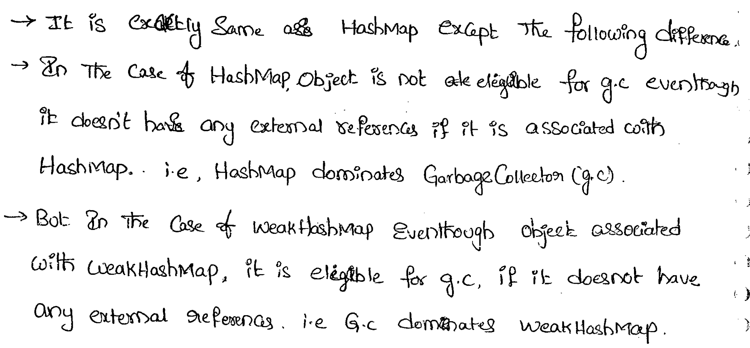
* SortedMap:
* TreeMap: underlying DS RED-Black Tree

**Queue**: where objects are inserted into one end of the queue, and taken off the queue in the other end of the queue

**Sorted**\*\*\* : Some sorting order

**Navigable**\*\*\* : added methods for Navigation

**Linked\*\*\***  : Insertion order preserved

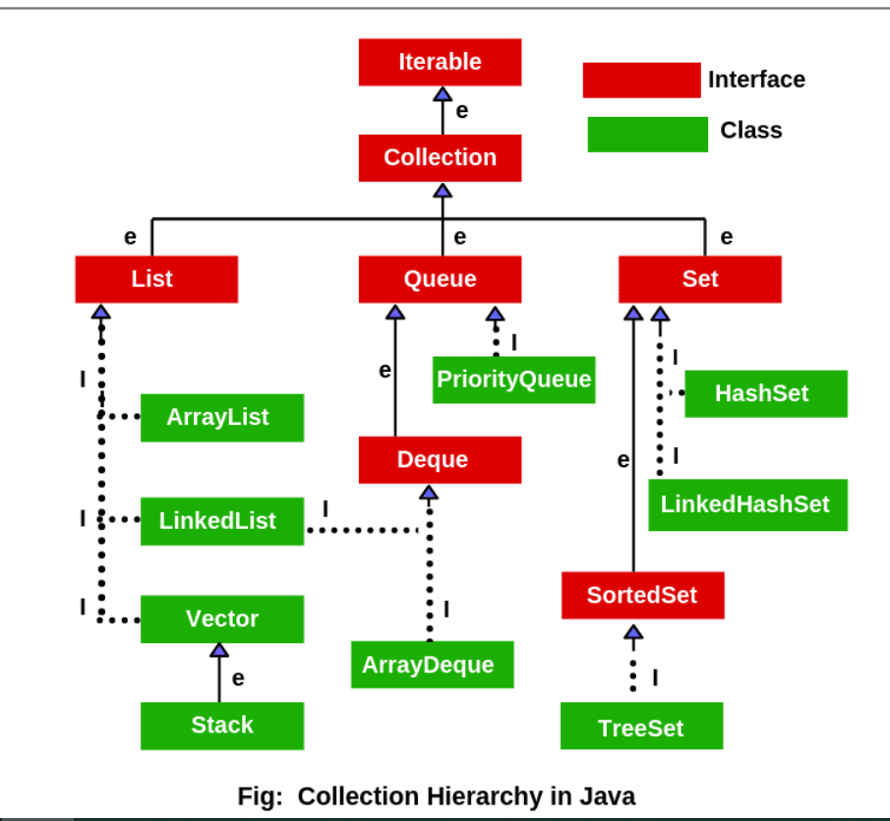

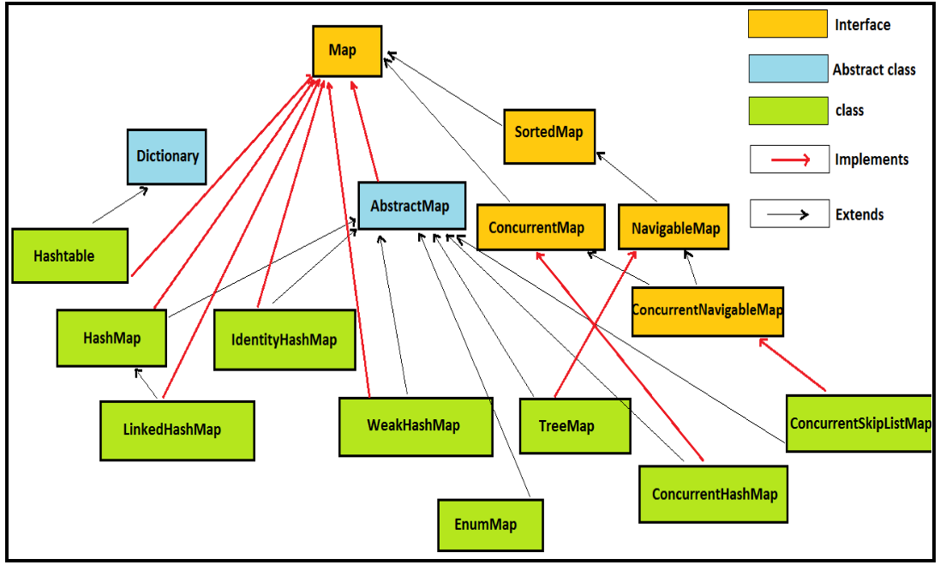--------------------------------------------------------------------------------------------------------------------------------

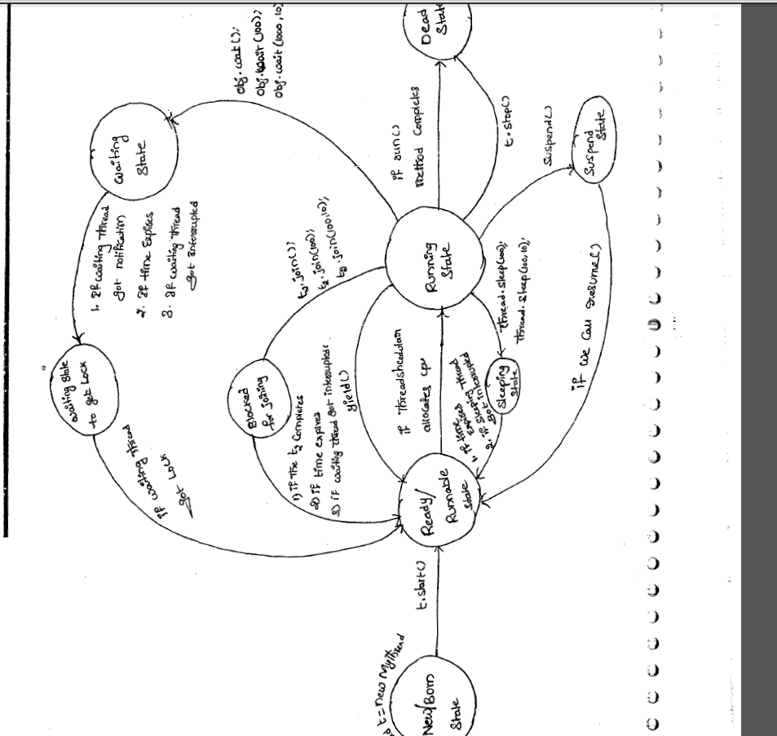

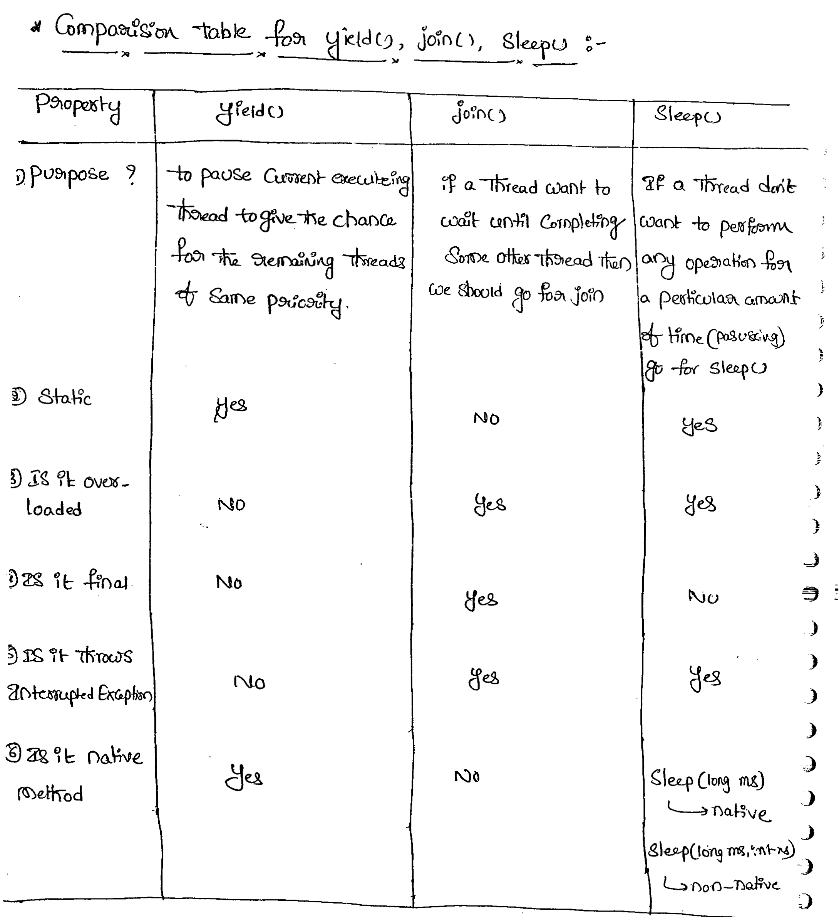

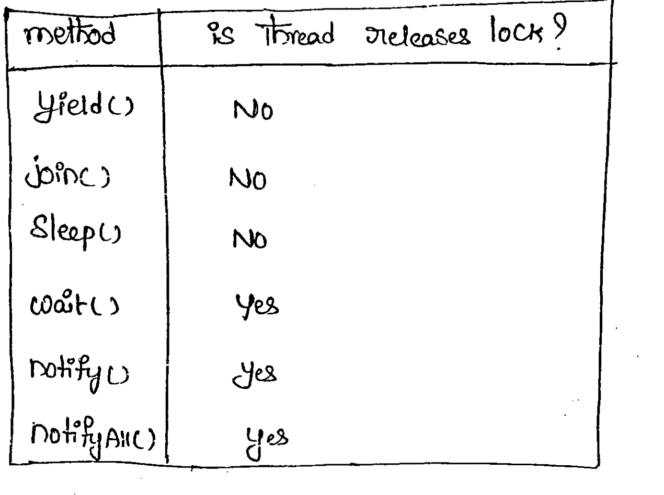

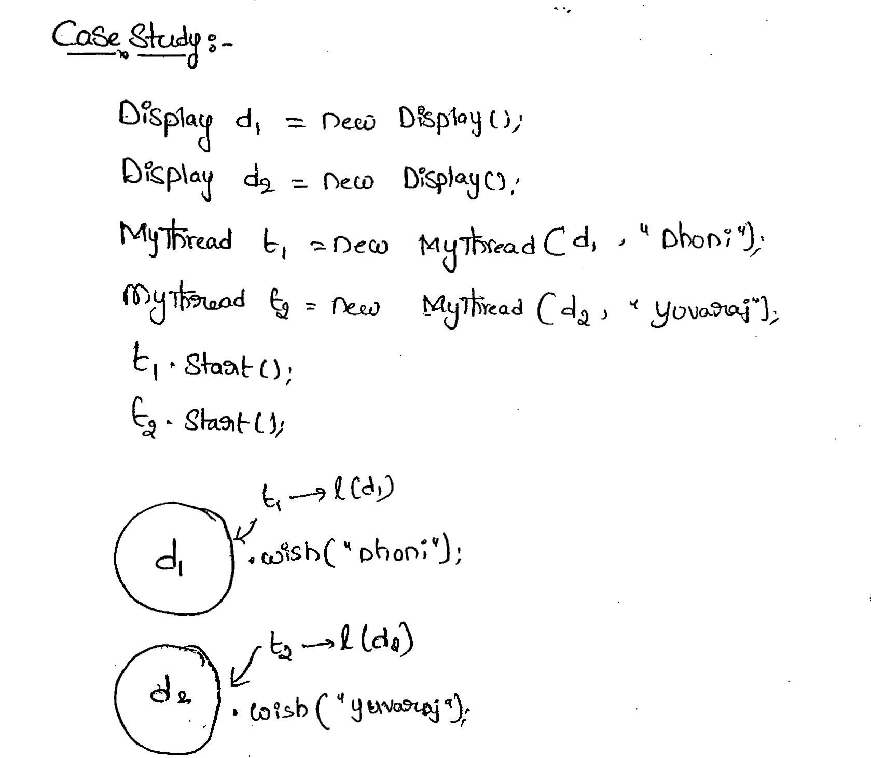

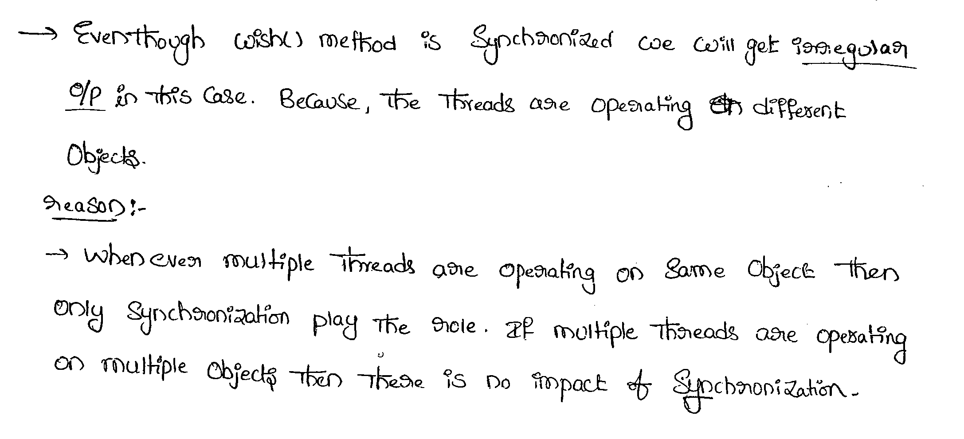

--------------------------------------------------------------------------------------------------------------------------------

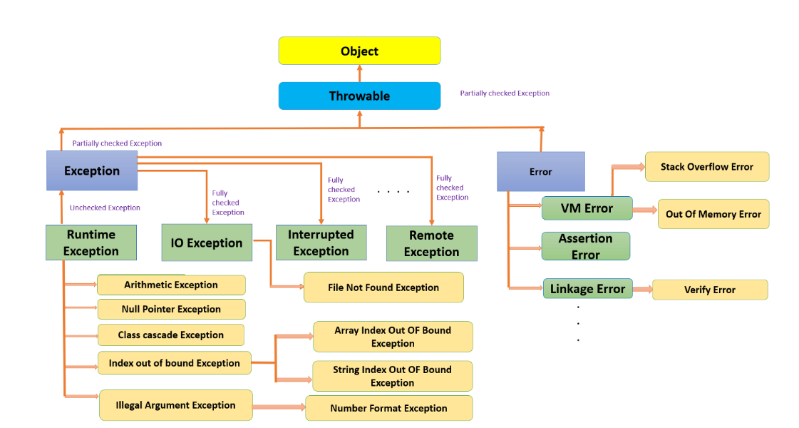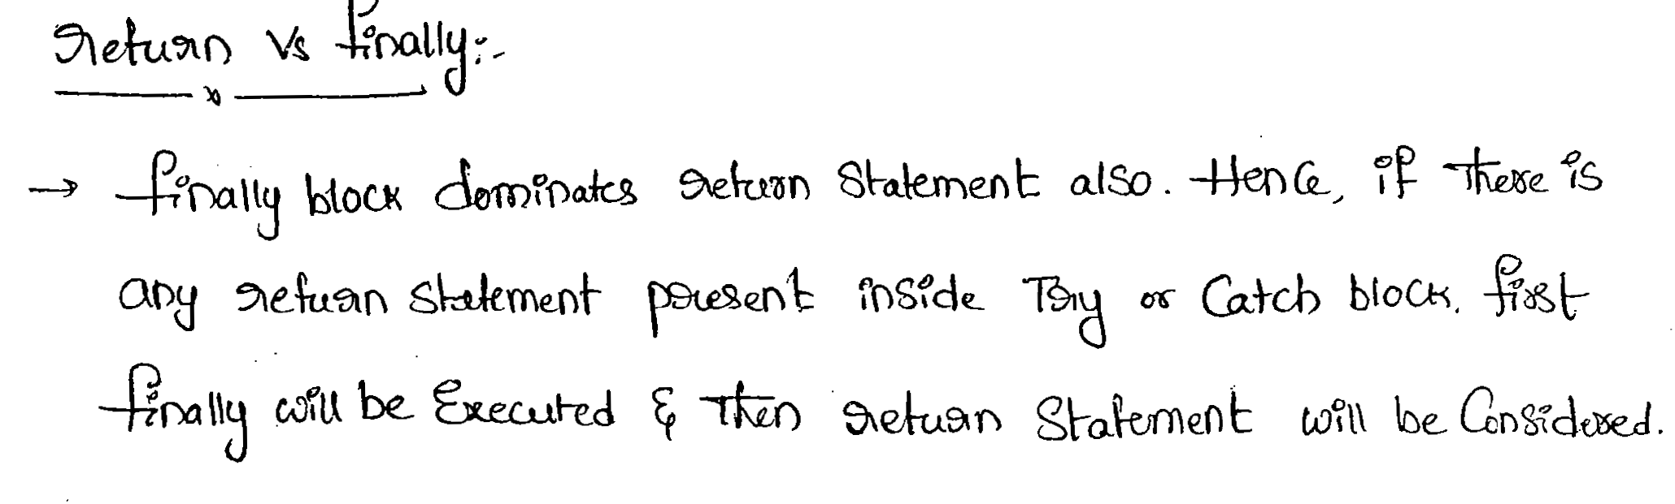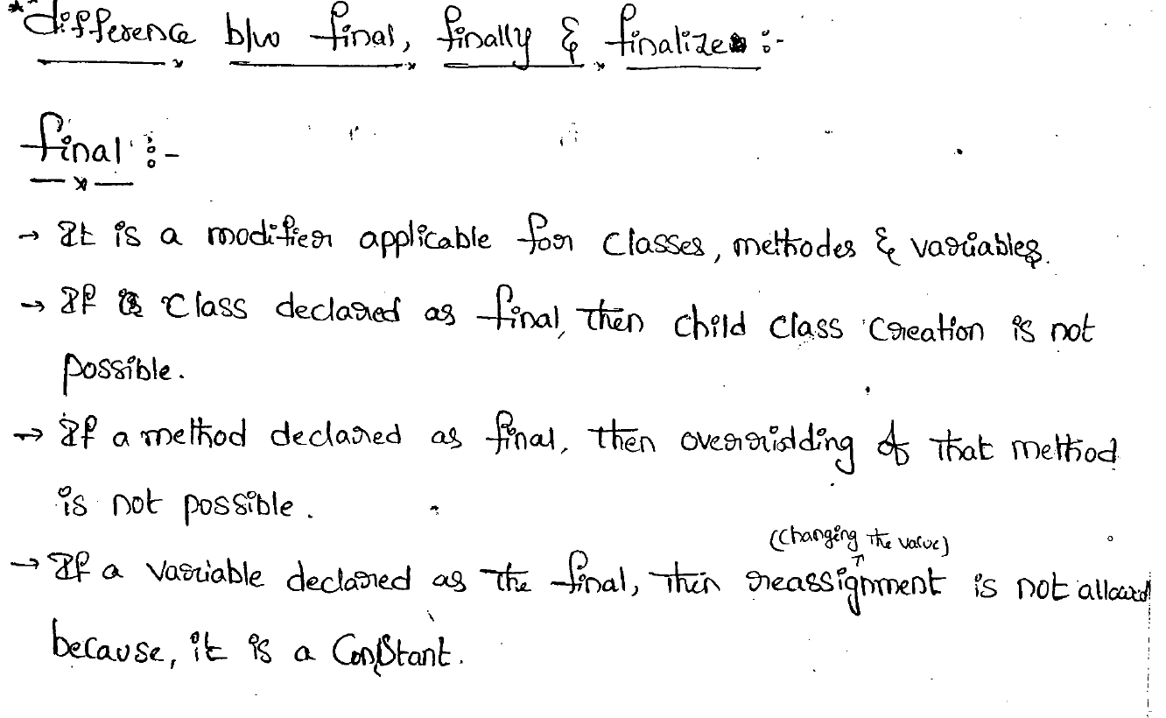

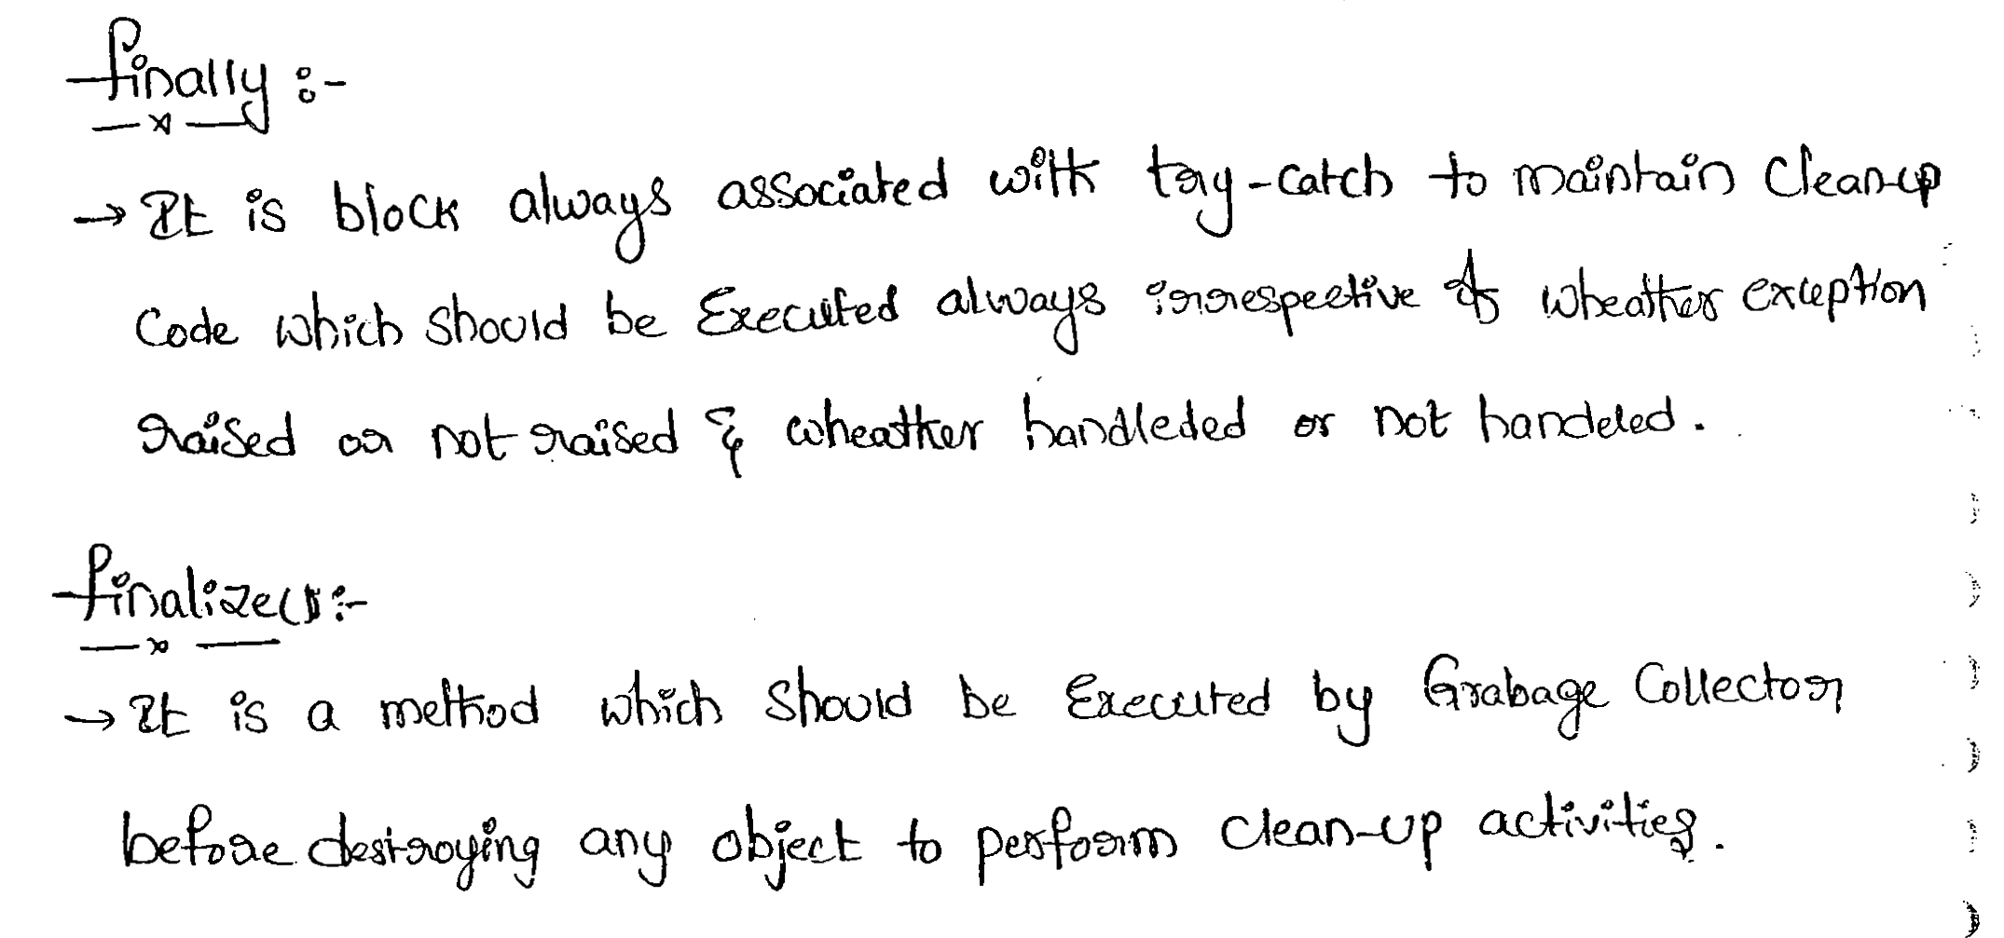

--------------------------------------------------------------------------------------------------------------------------------

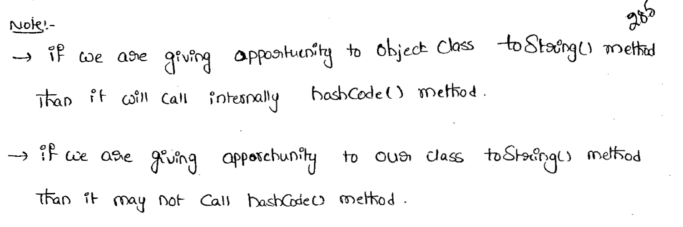

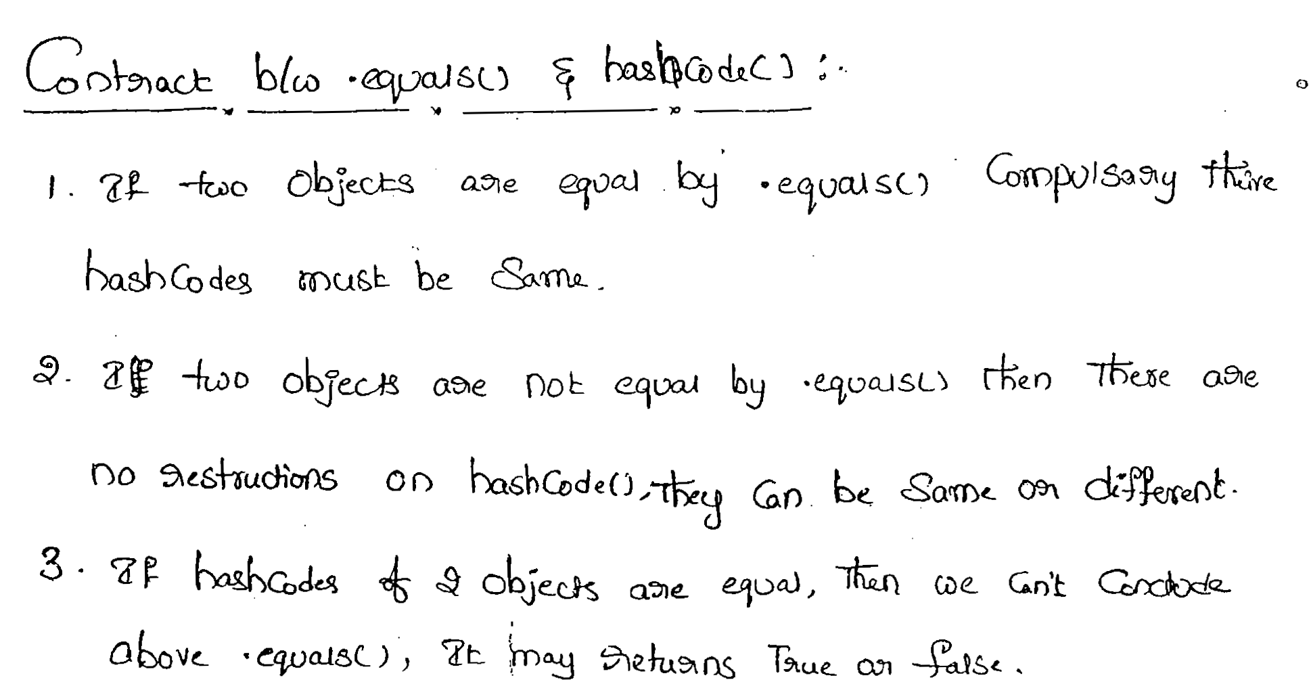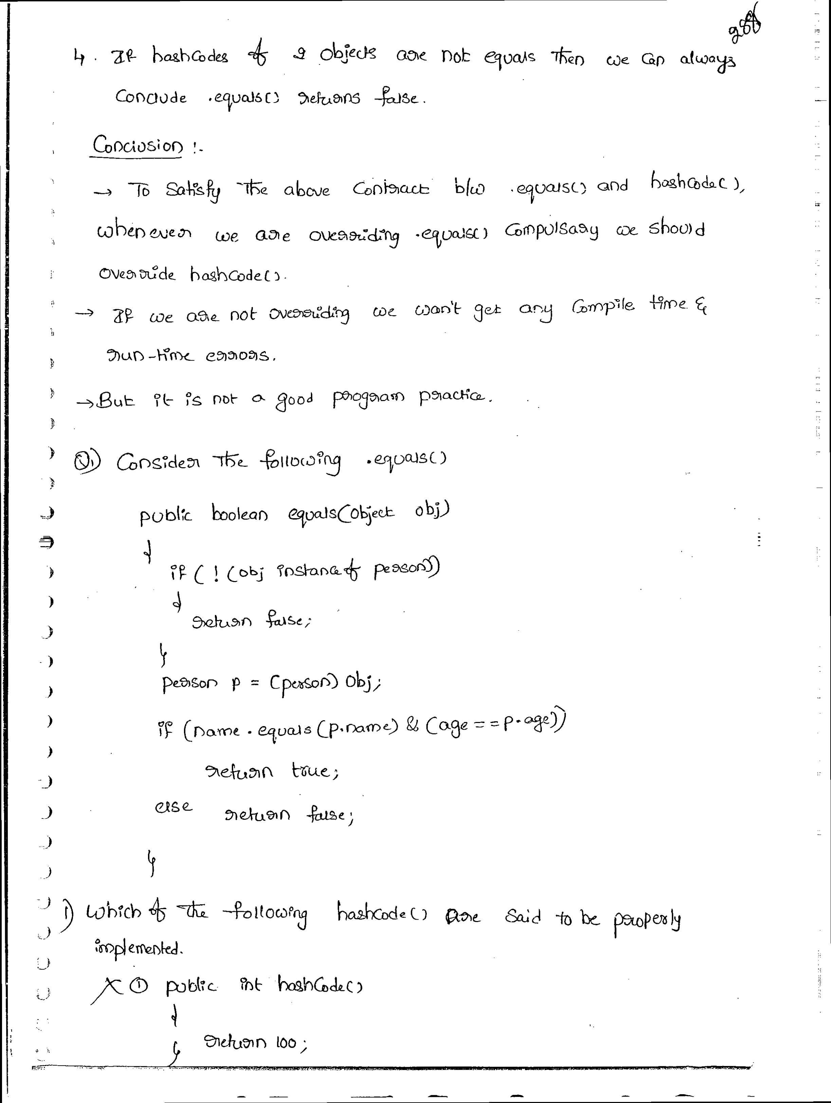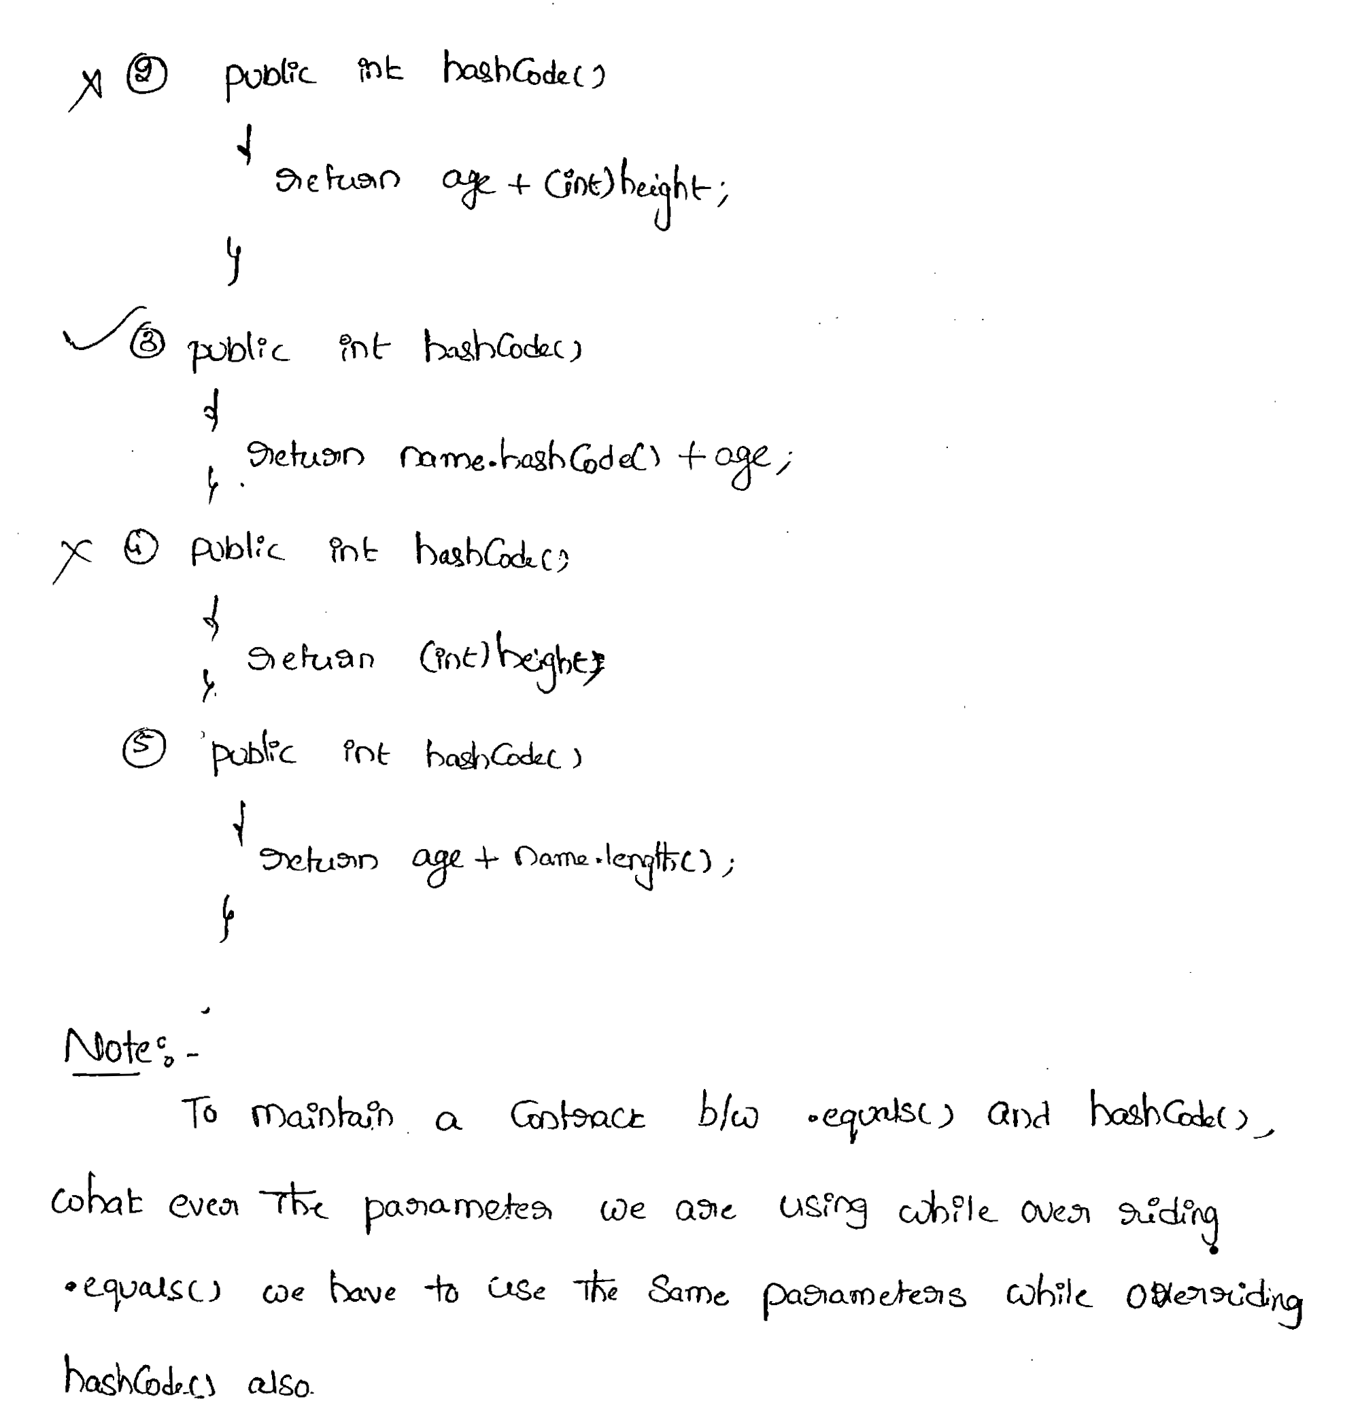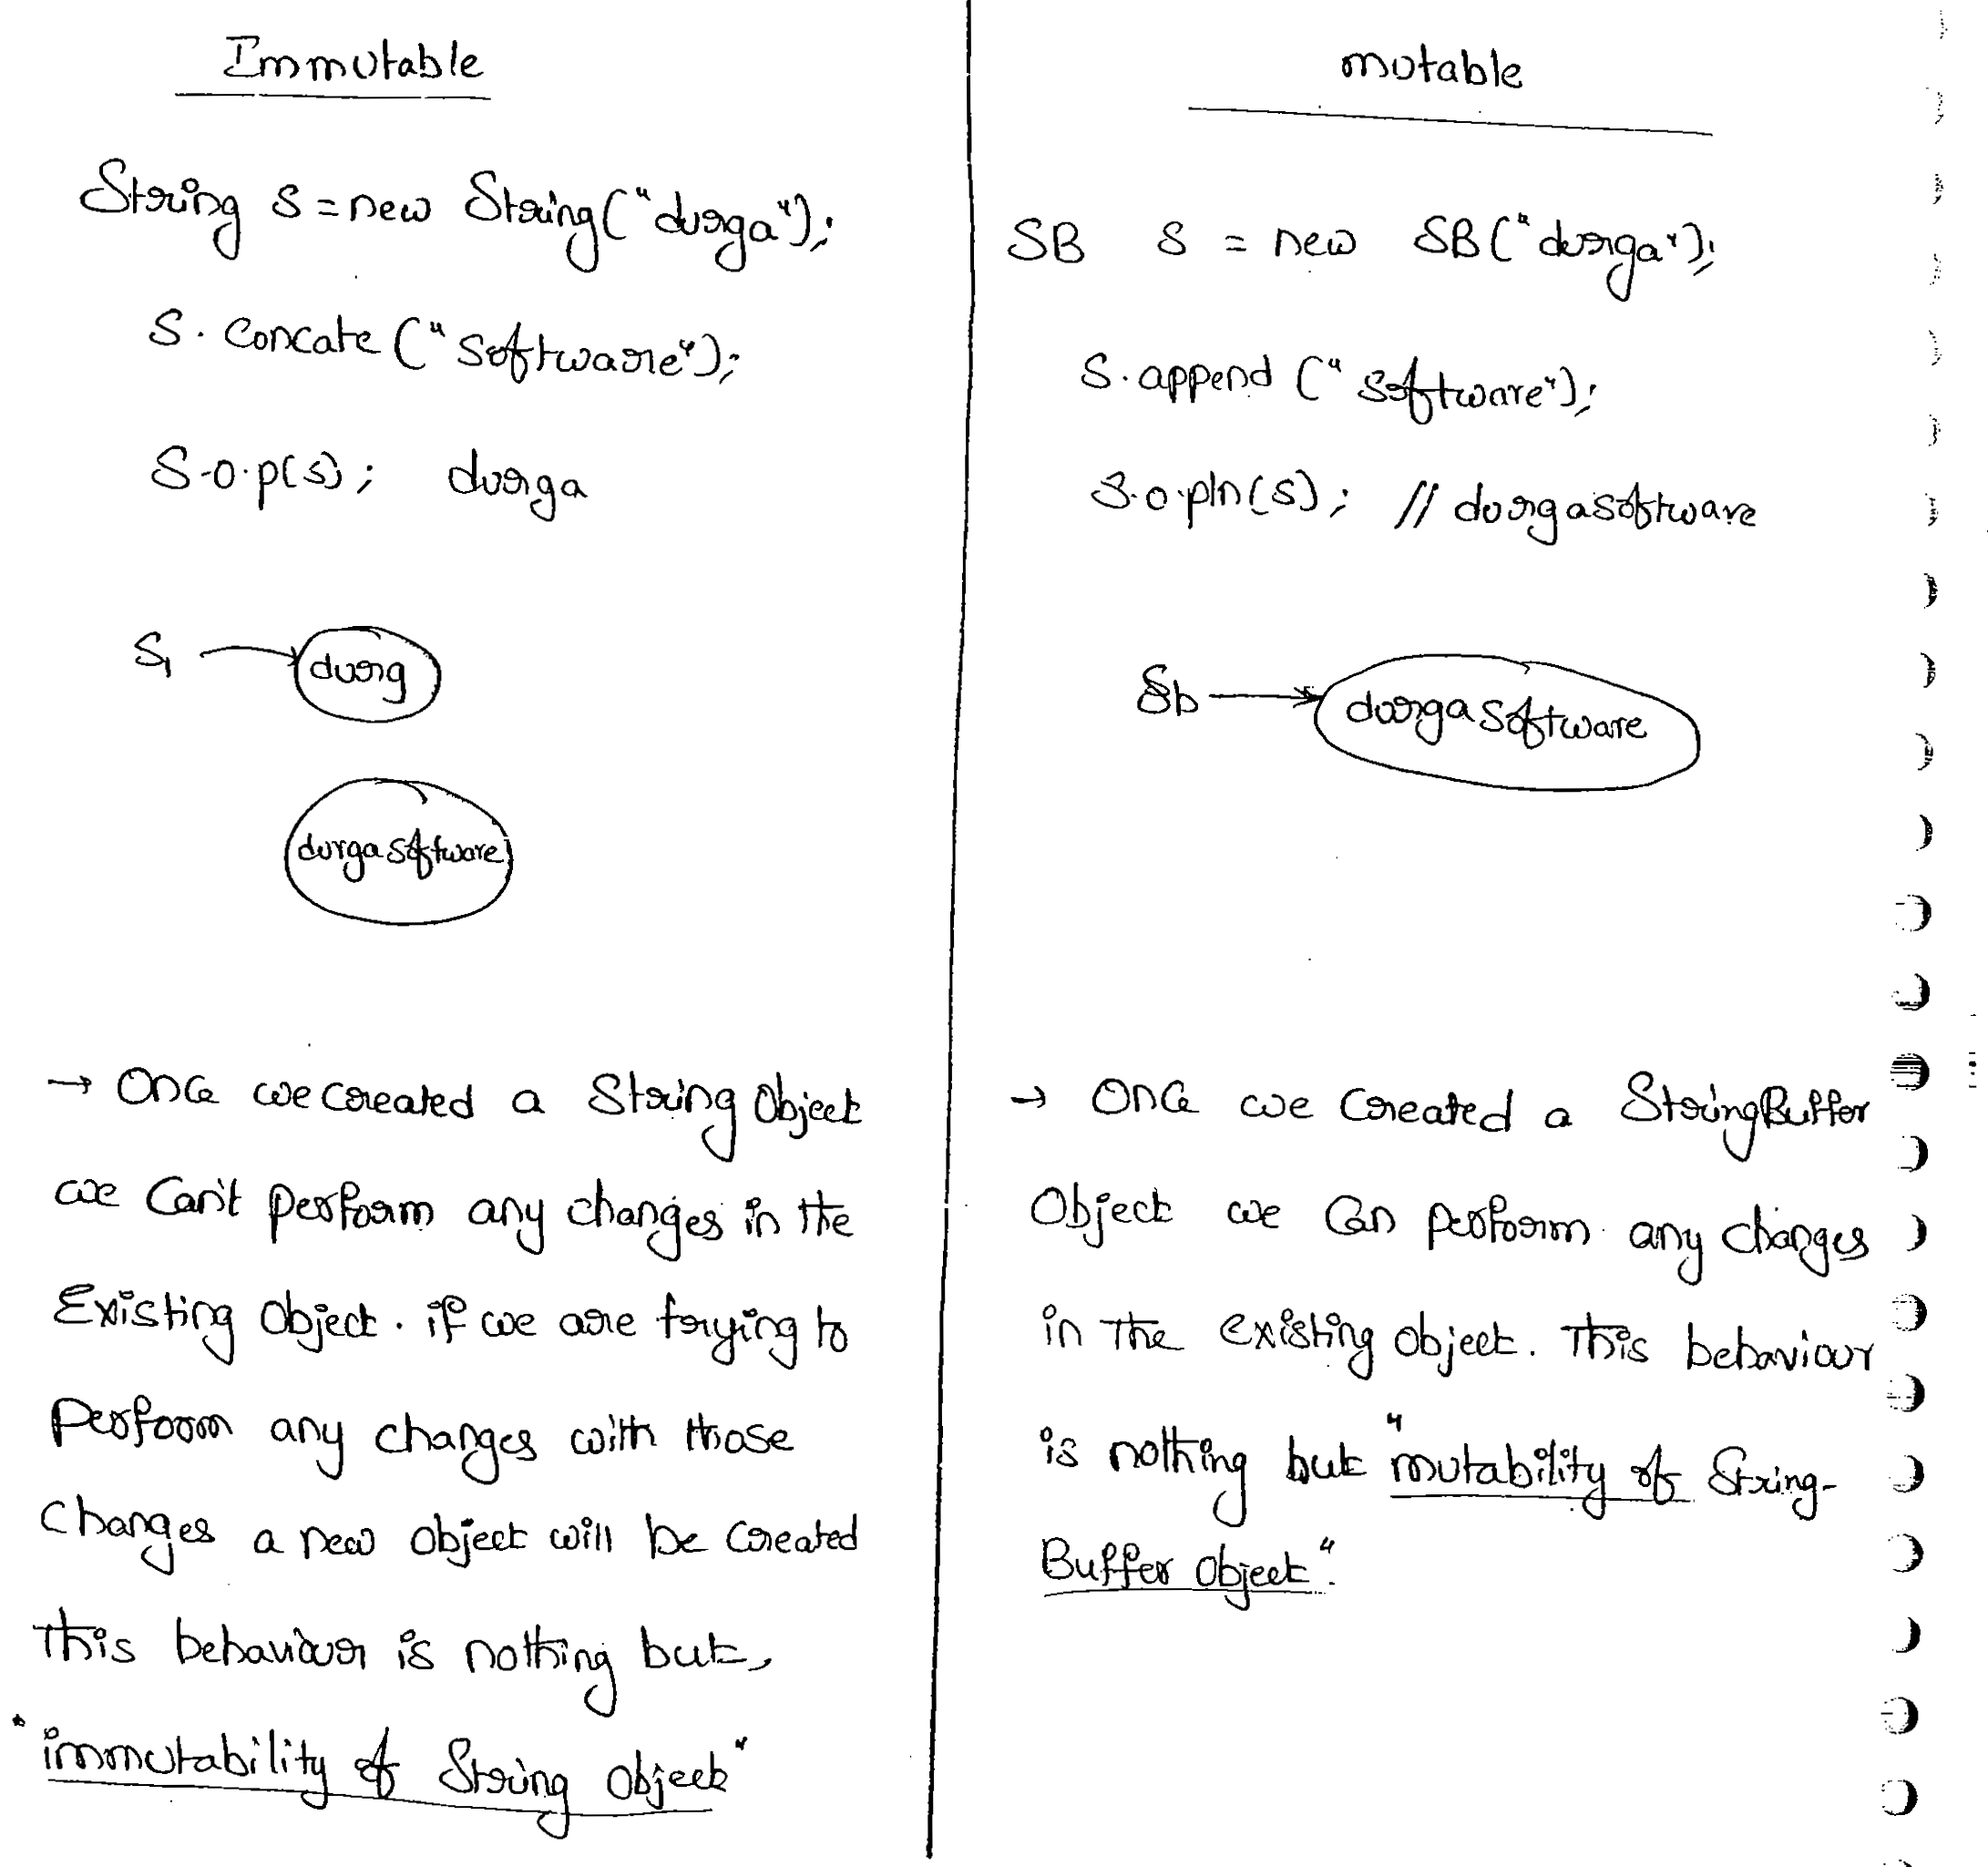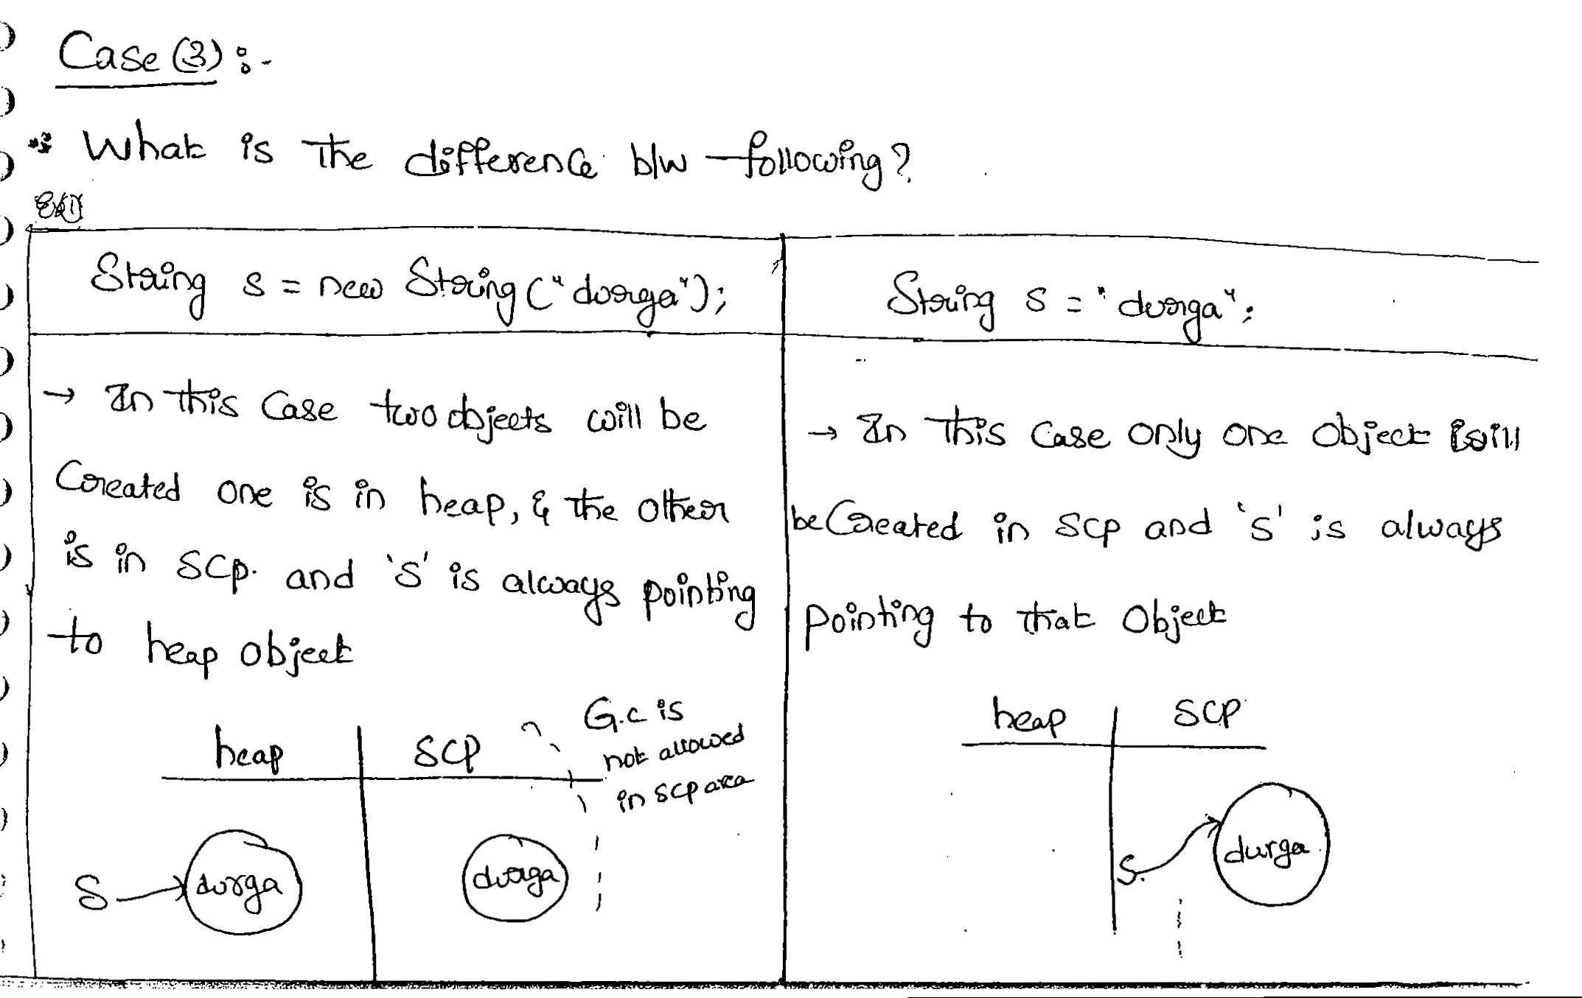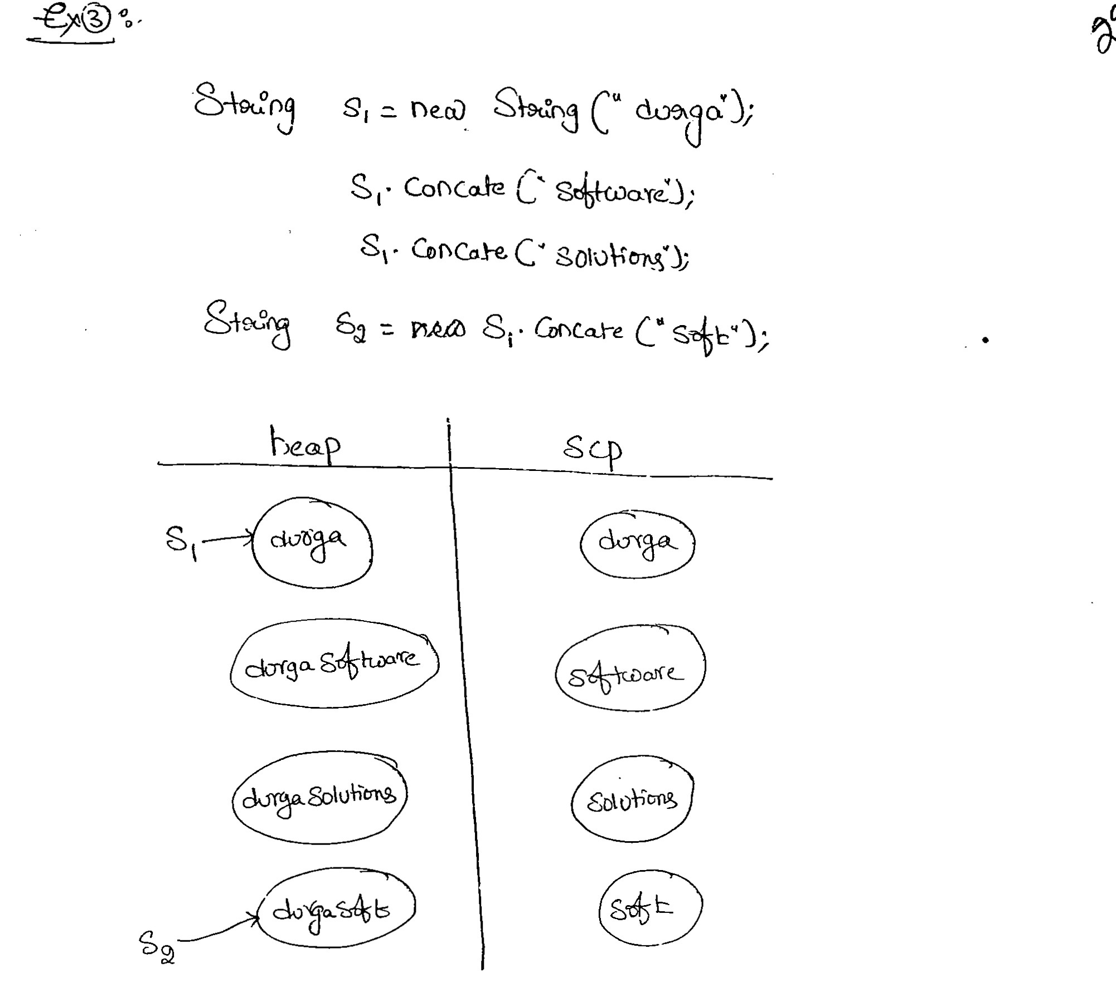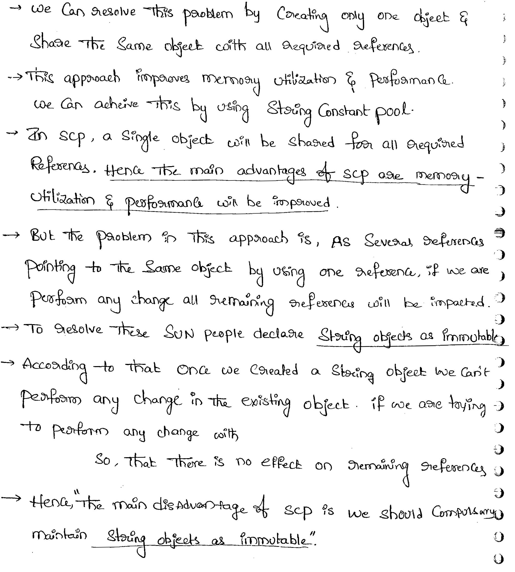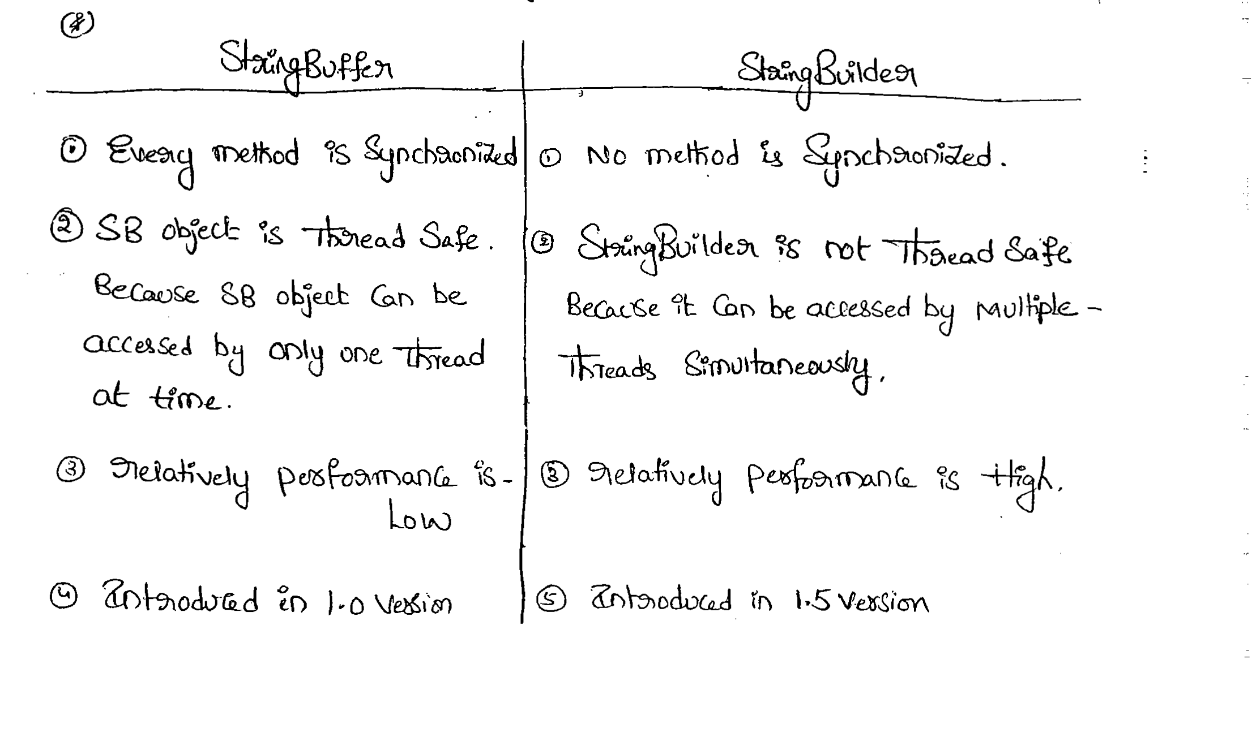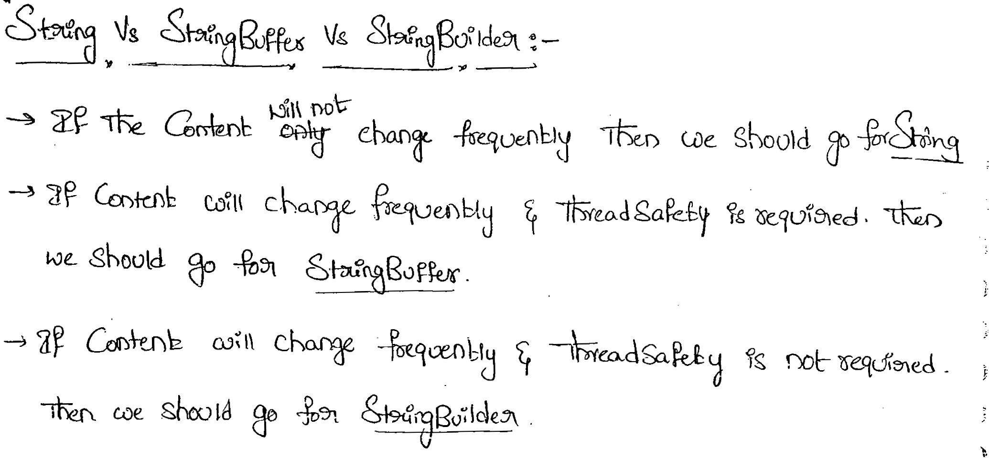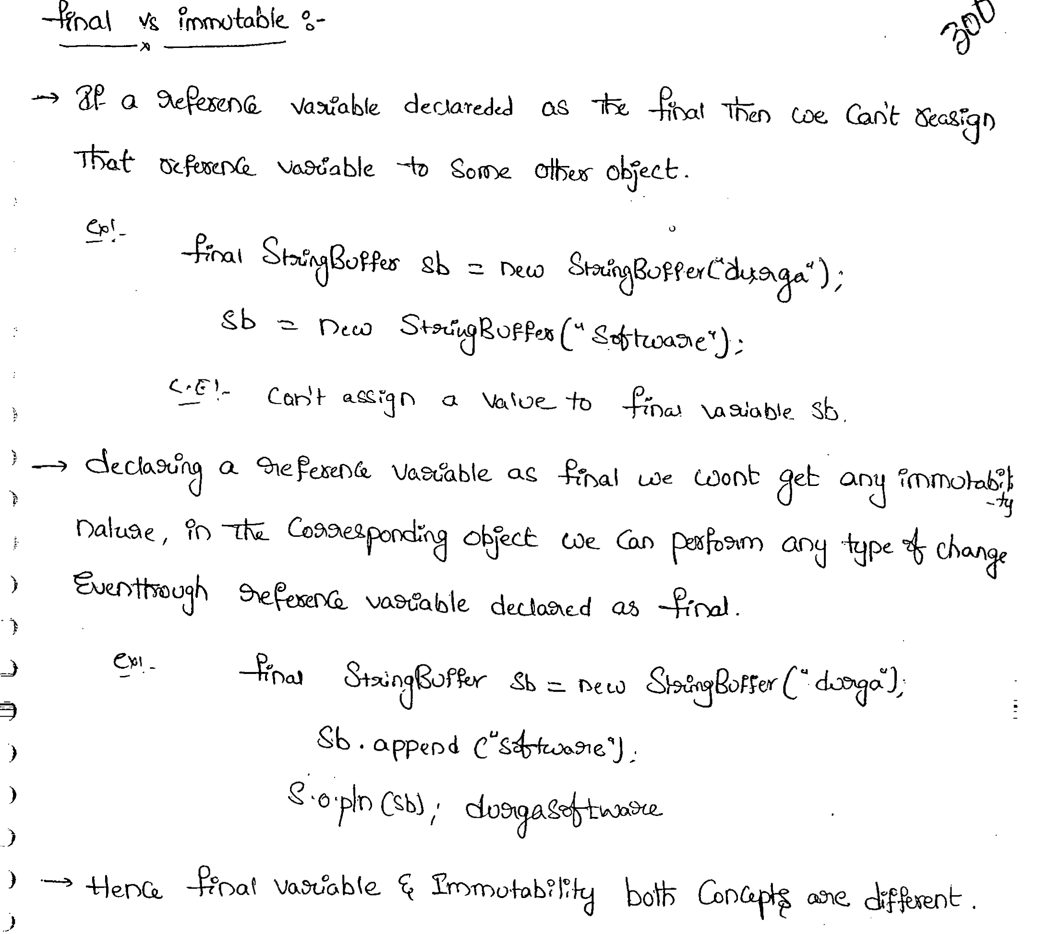

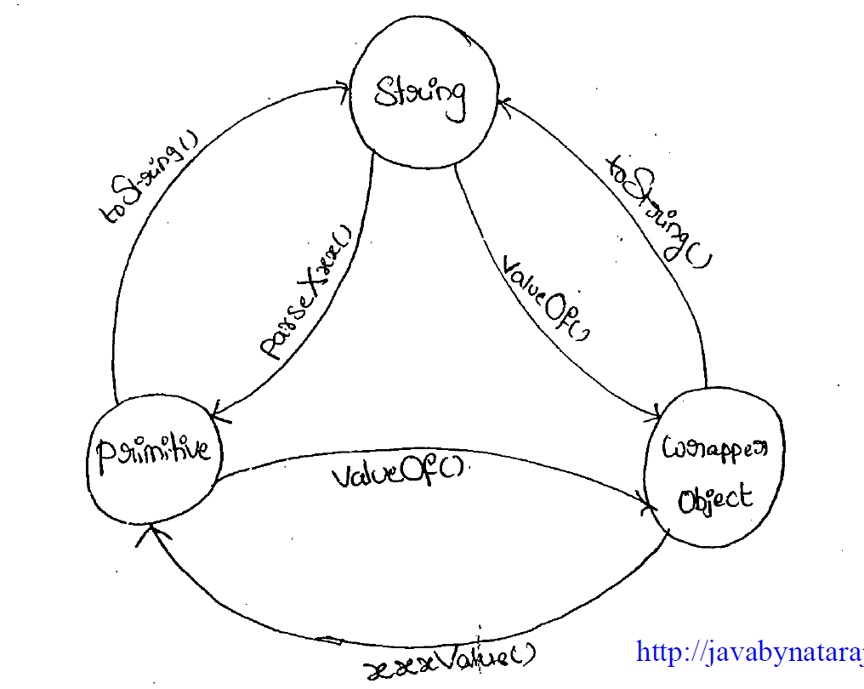

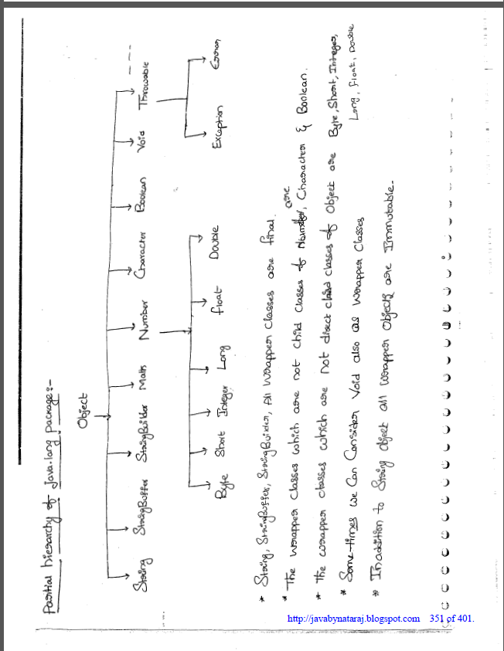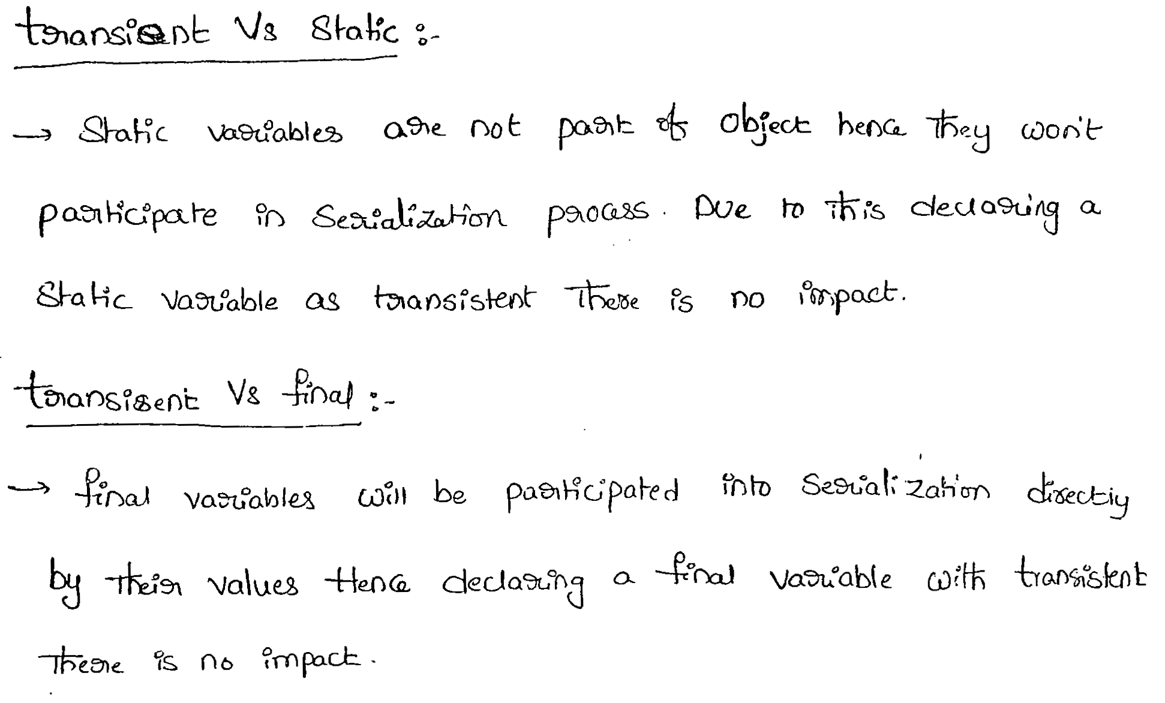

------------------------------------------------------------------------------------------------------------------------------------------

Inheritance ex.

1. When parent and child have different name methods (No Overriding)

|  |
| --- |
| class Vehicle{  void run(){  System.out.println("Vehicle is running");  }  }    class Bike1 extends Vehicle{  void run1(){  System.out.println("Bike is running safely");  }  }  class Bike2 {  public static void main(String args[]){  Vehicle obj = new Bike1(); //Cases  obj.run(); //Cases  }  } |

Case 1:

Vehicle obj = new Bike1();

obj.run();

Output: Vehicle is running

Case2 :

Vehicle obj = new Bike1();

obj.run1();

Output: **Compile by: javac Bike2.java**

122.93/Bike2.java:16: error: **cannot find symbol**  
 **obj.run1();**  
 ^  
 symbol: method run1()  
 location: variable obj of type Vehicle  
1 error

1. When parent and child have same name methods (Overriding)

|  |
| --- |
| class Vehicle{  void run(){  System.out.println("Vehicle is running");  }  }    class Bike1 extends Vehicle{  void run(){  System.out.println("Bike is running safely");  }  }    class Bike2 {  public static void main(String args[]){  Vehicle obj = new Vehicle(); //Cases  obj.run(); //cases  }  } |

Case1:

Vehicle obj = new Vehicle();

obj.run();

Output: Vehicle is running

Case2:

Vehicle obj = new Bike1();

obj.run();

Output: Bike is running safely